Pheonix 3d Printed Quad Copter Assembly Instructions

# C:\Users\Alex\Documents\GitHub\Pheonix_3dPrinted_Quad\Manual\Images\20141213_235406.jpg

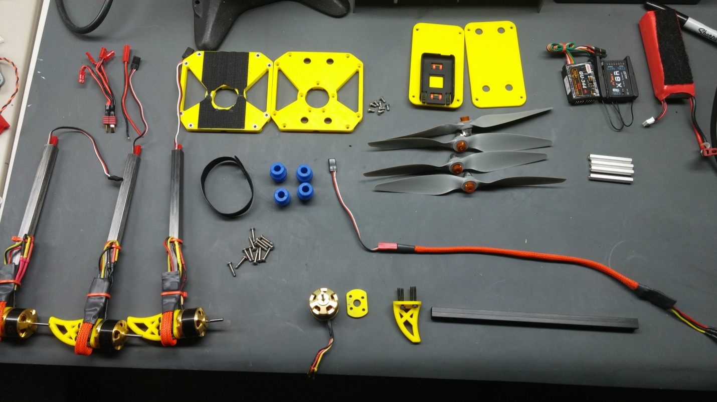

# Arm Assembly:

To begin the assembly we will start by assembling one of the arms. Start by taking one of the carbon booms and, using a rat tail file make clearance for the screws to go around the bar as in the picture.

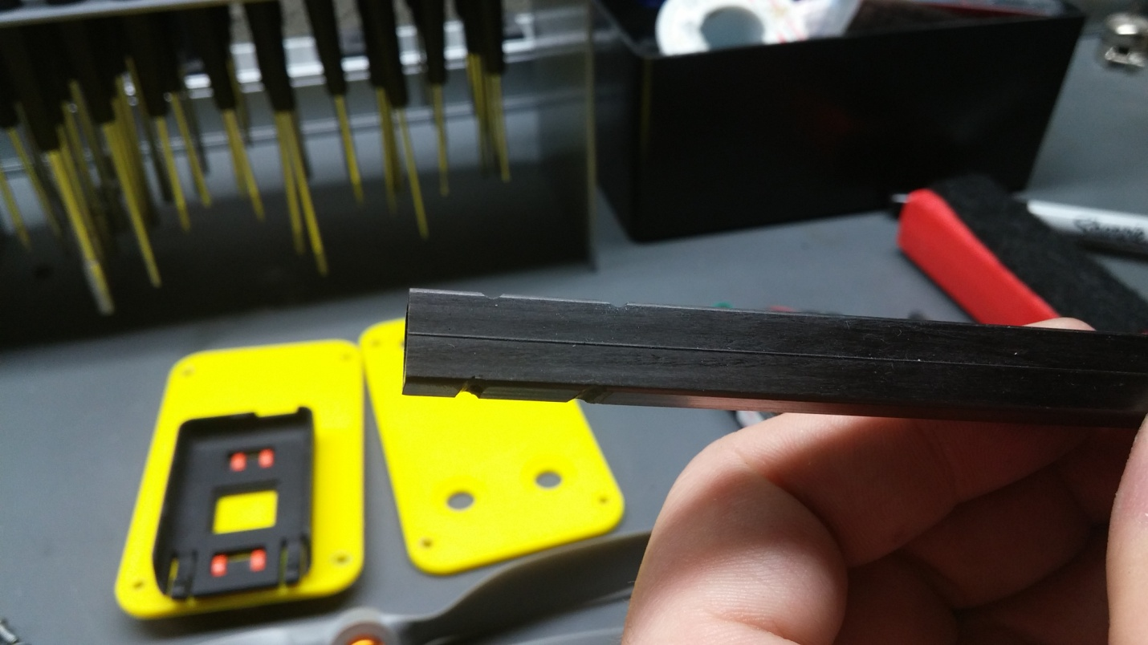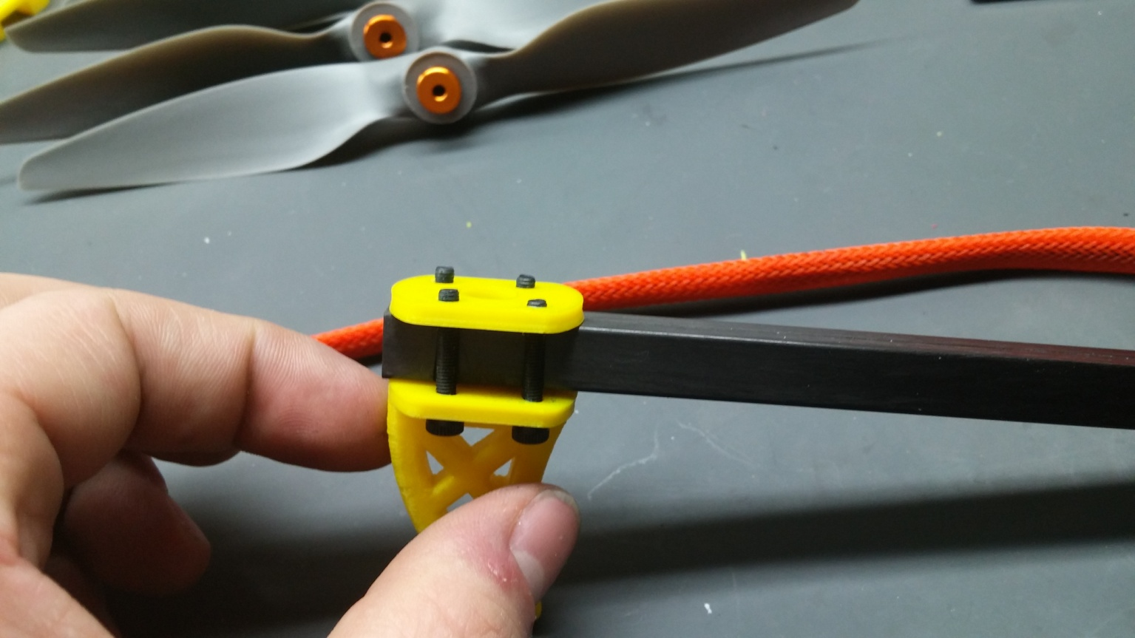

These grooves need to line up with the bottom motor plate to allow for the motor to be assembled as shown on the right. Once the screws are fit, they just need to be threaded into the motor and tightened down.

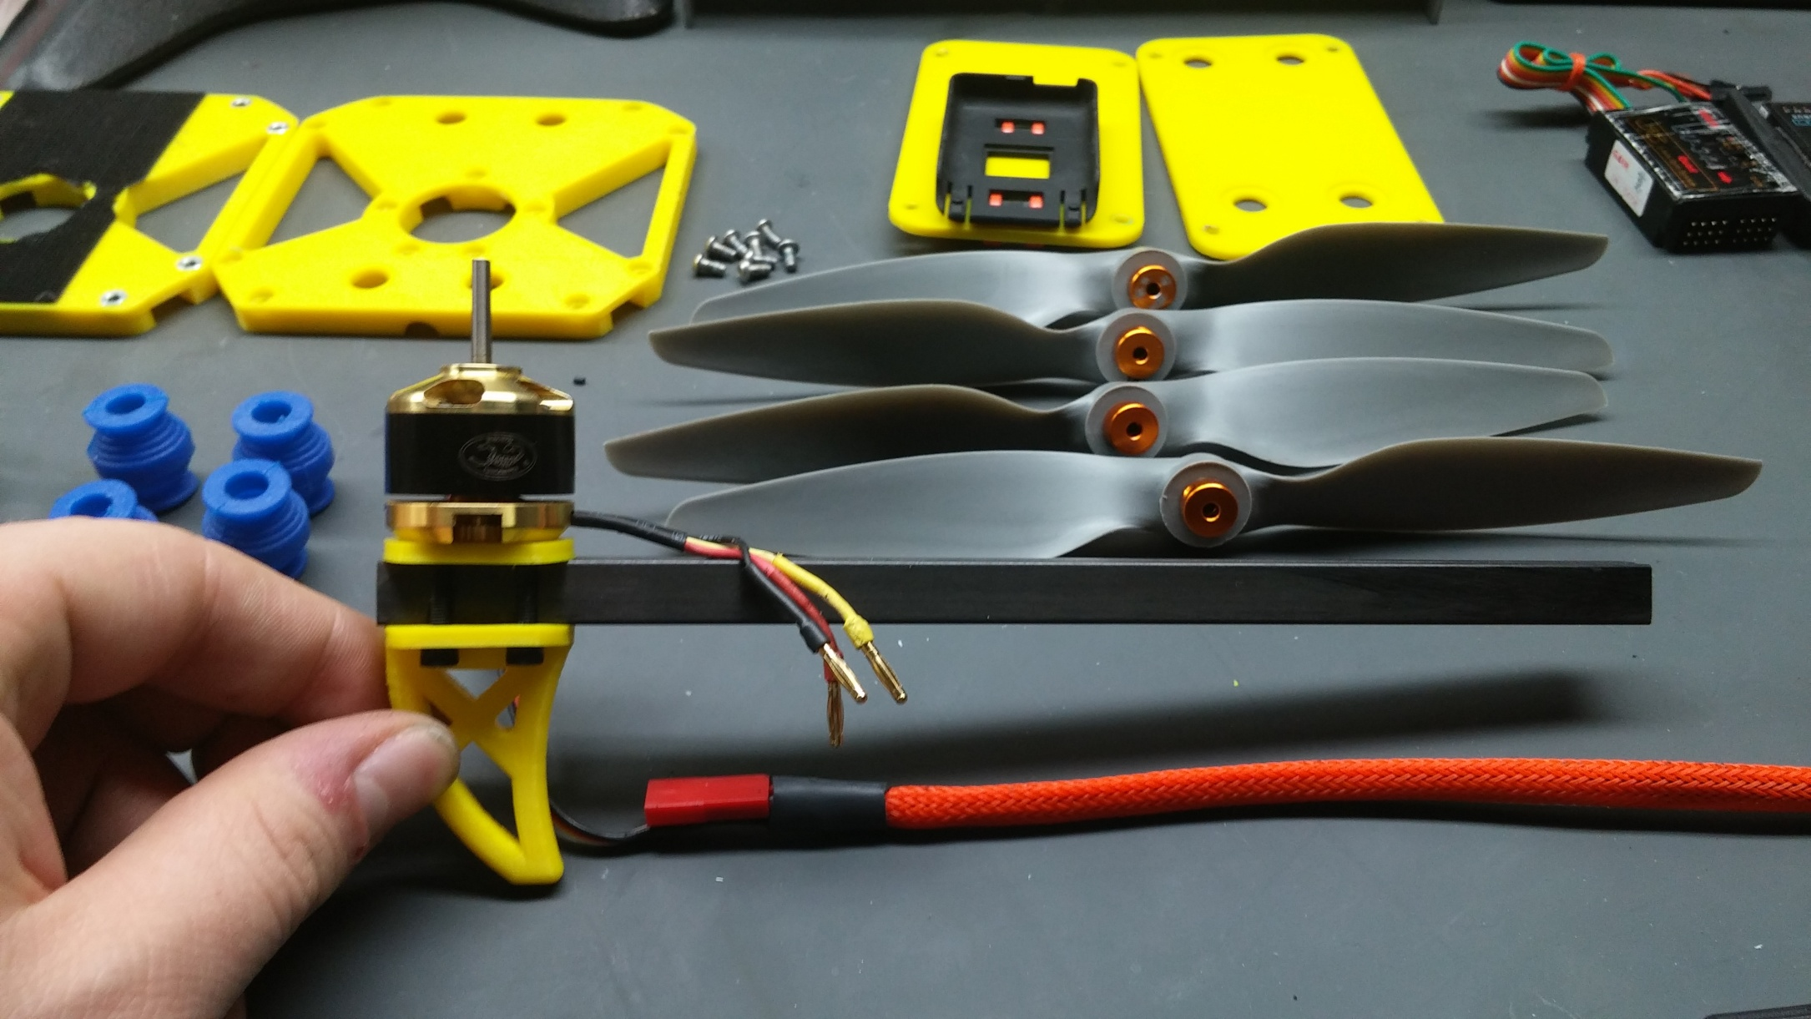

This should be the end result. Now you want to feed the speed controller through the center of the arm and then bend the wires to the outside of the arm then loosely cable tie the esc to the arm as shown.

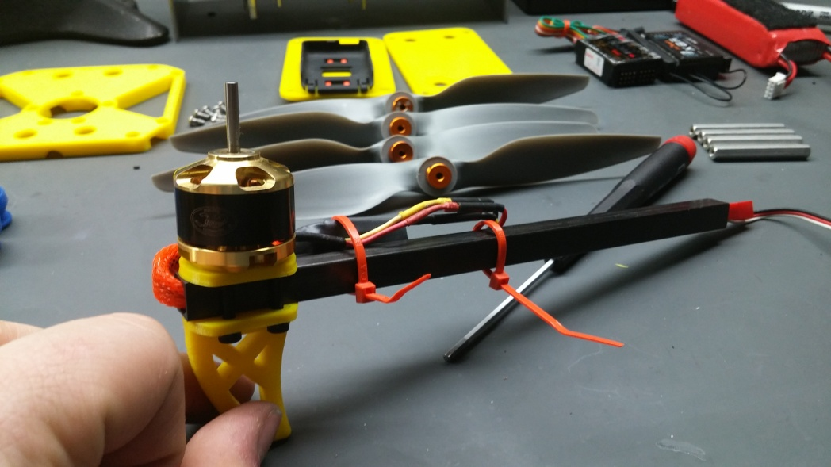

This completes the arm assembly now just repeat this 3 more times to complete the arm assembly.

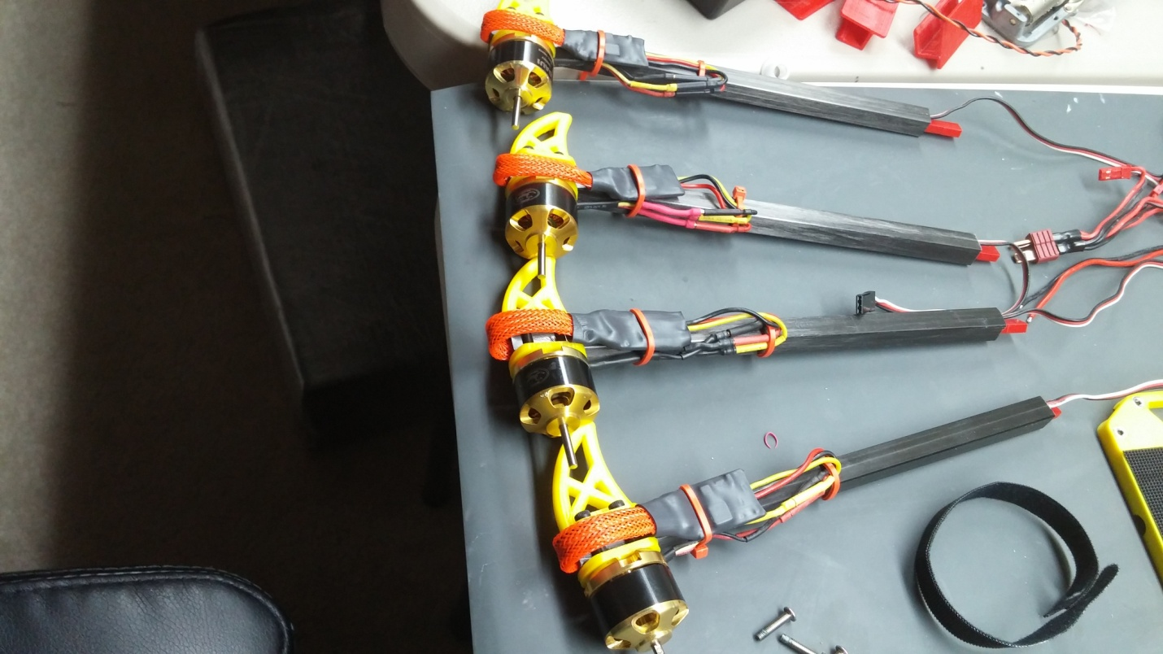

# Center Section Assembly

Now I used this power harness I made, t connector in to 5 jst connectors out. The harness will need to be approximately 3” long.

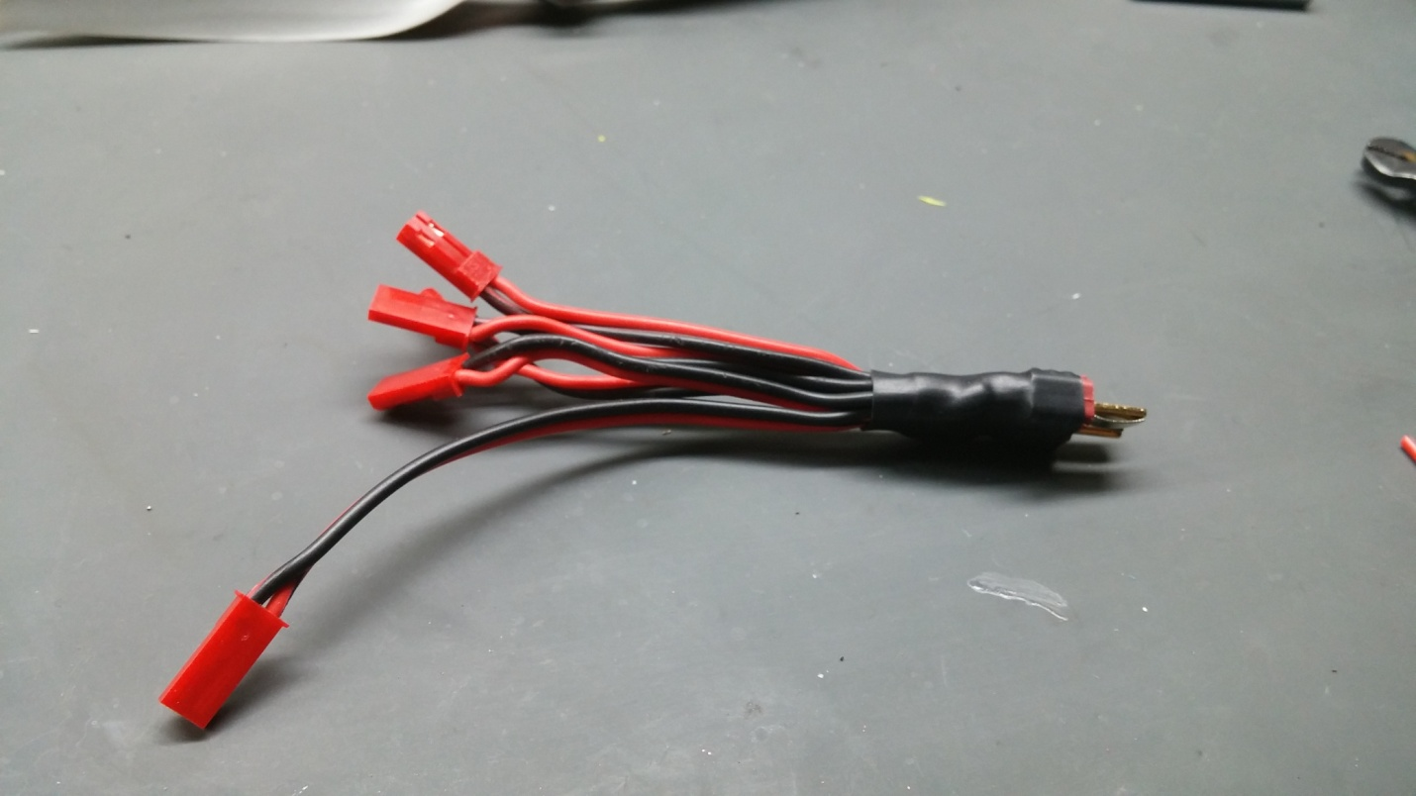

## Bottom Plate

Press the hex nuts into the bottom plate as shown.

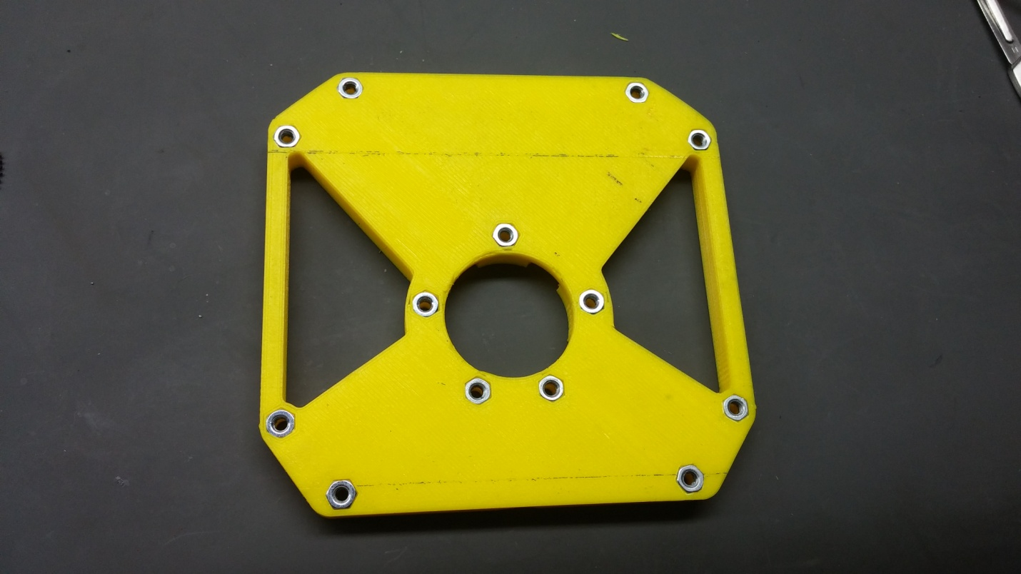

Now you need to add a strip of self adhesive Velcro to the bottom of the plate.

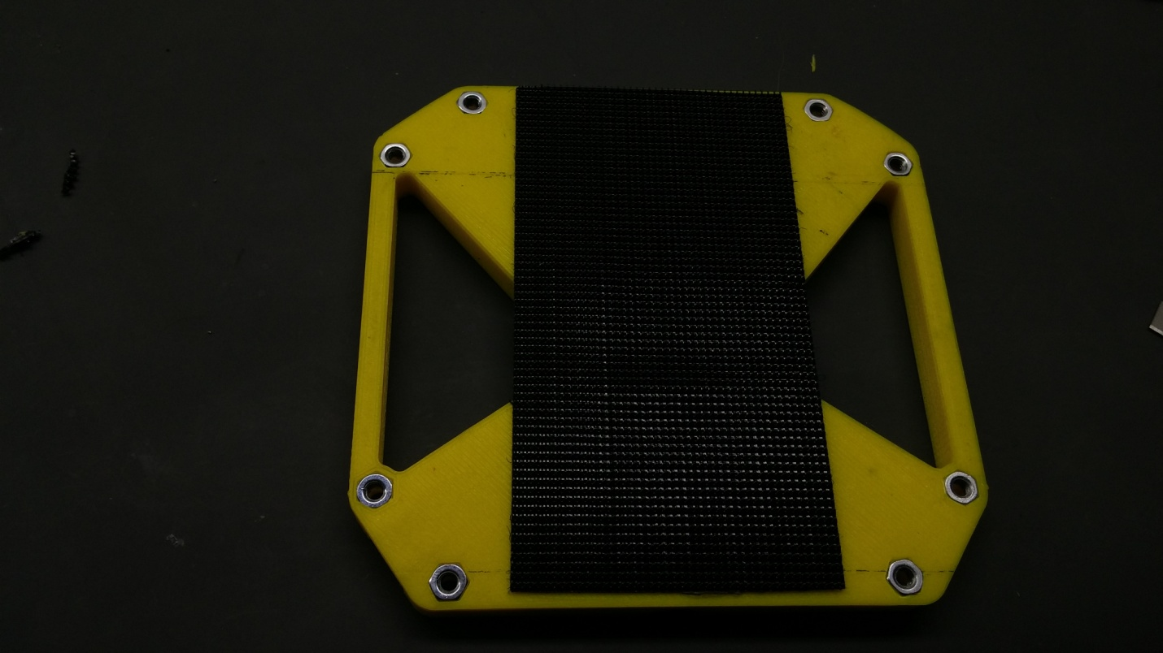

Now just trim the Velcro to the edges of the plate so that it looks nice and clean as shown below.

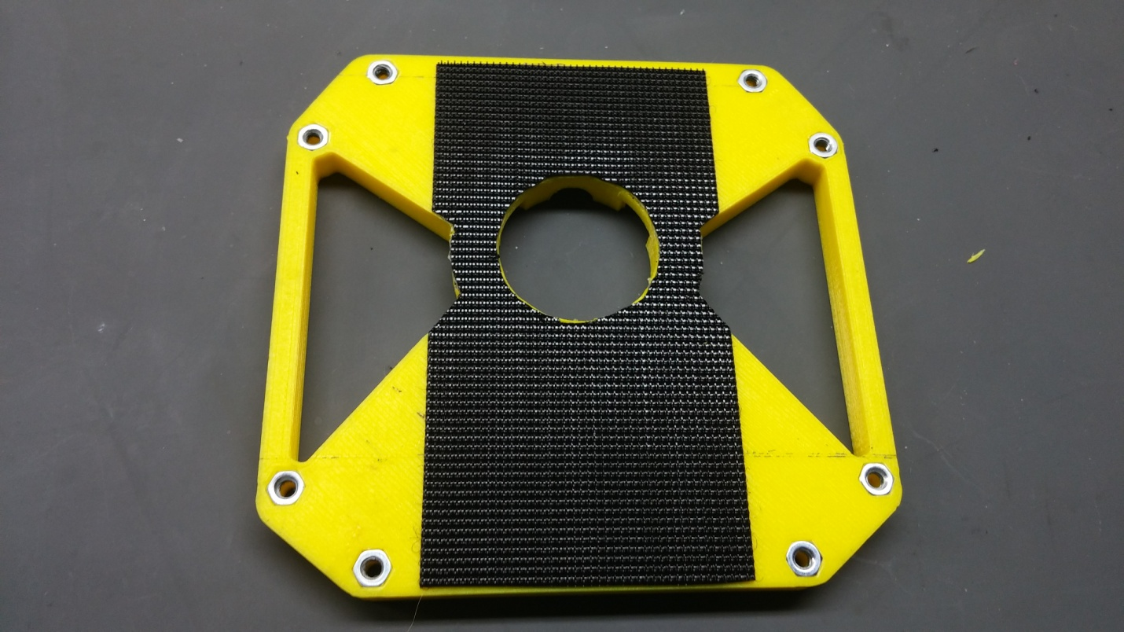

The bottom plate is now finished.

## Wiring and center assembly

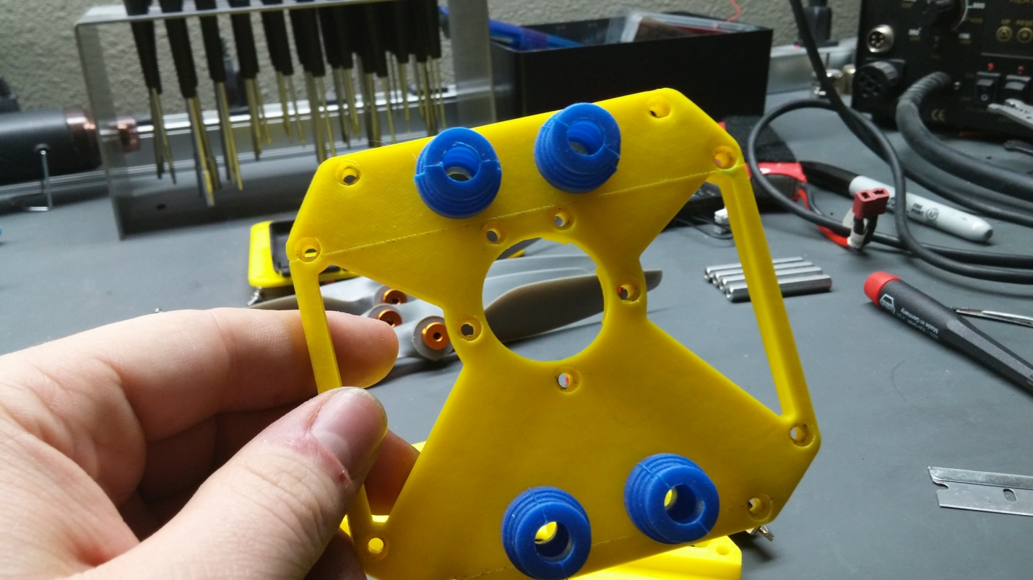

Start by putting the vibration mounts in the top plate as shown.

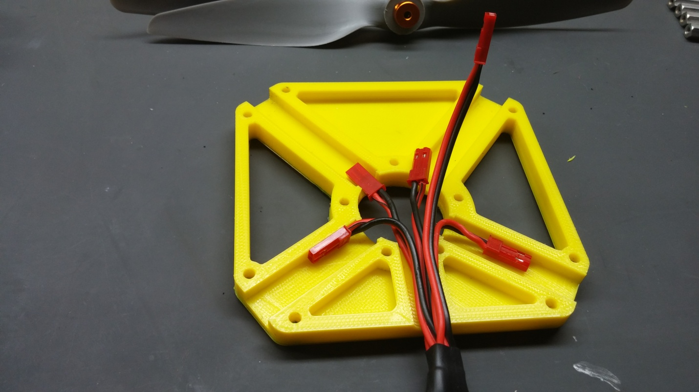

Now lay out the wiring harness as shown, the long wire is for fpv power and will be passed through the center hole. Finally just bolt the center section together loosely and be careful not to pinch the wires.

Feed the arms into the center section and plug the power lines into the wiring harness as shown, and run the servo wires out the top.

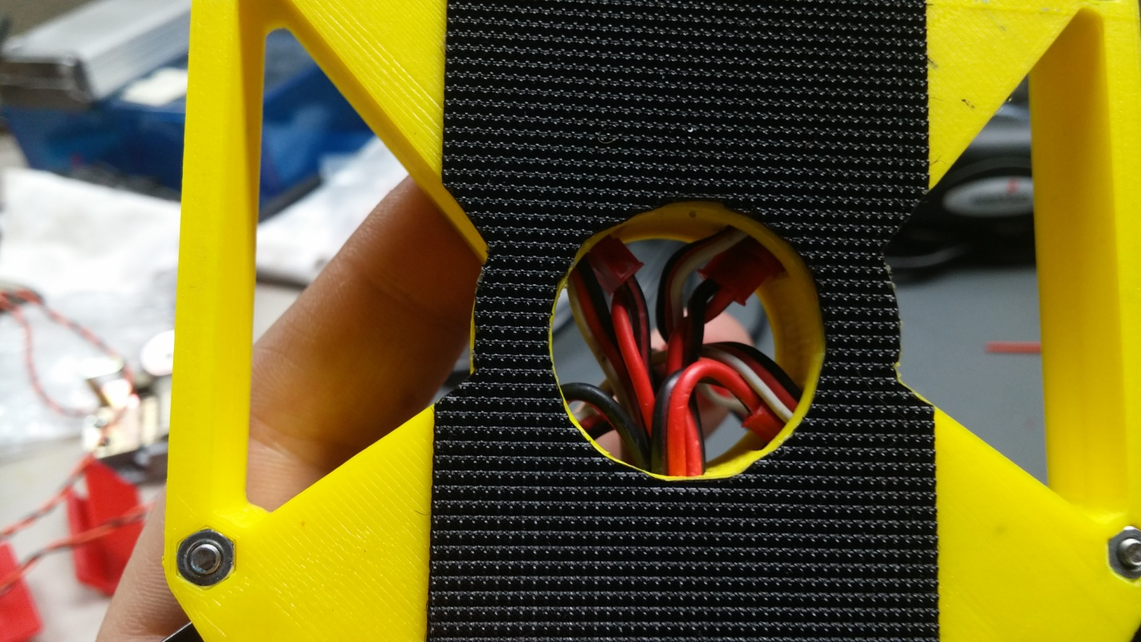

Main frame complete!

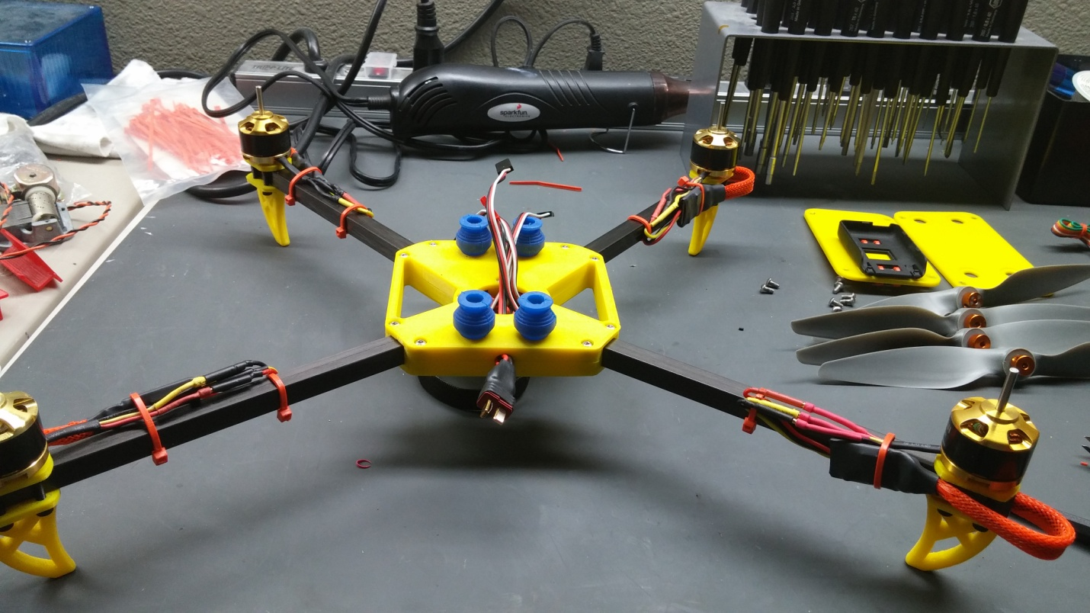

# Clean plate

Start by assembling the bottom clamp plate with the standoffs as shown taking care to make the countersinks on the plate go in the direction shown.

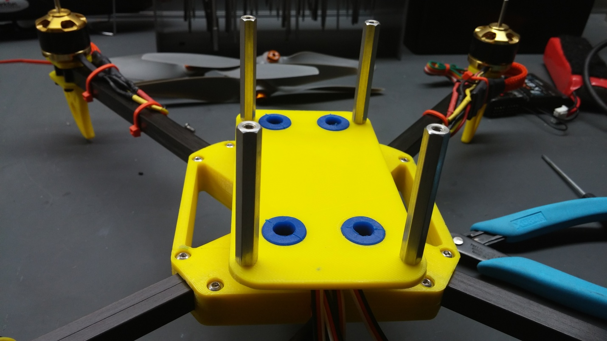

Mount the bottom plate to the frame using the isolators as shown.

Finally bolt on the top plate and assembly is complete.

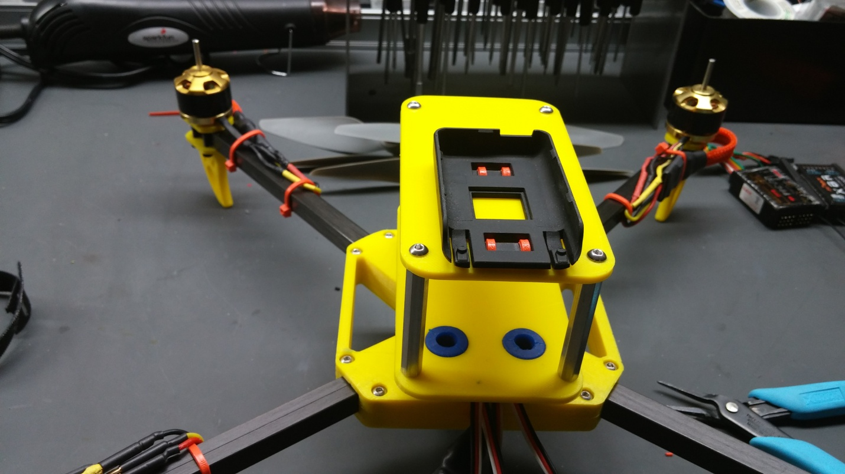

Finish wiring and setting up your system and you’re done!

